Template
Everyone Has a Story to Tell
- Don’t forget to refer to the Step-by-Step Guide if you need help. Page 8-12 has suggestions.
- Begin with your title page, but if you’re not too sure, you can always decide later. For the time being, just write, ‘My Story’ and carry on from there. One day, the final title will make itself known to you.
- You might want to experiment with different fonts and font sizes. The Step-by-Step Guide uses the Verdana Font, but we’ve switched to the Lucida Calligraphy Font here. There are so many different choices!
- That’s it. ‘Is everyone sitting comfortably? Then we’ll begin.’
- Enjoy.
Step One : Your Title Page

Step Two: Your Blank Timeline Grids
- Find your starting decade timeline grid, deleting the grids that don’t apply to you.
- Then, beginning with your birth year, carry on completing each decade until you reach the present year.
- Check the Step-by-Step Guide if you need any reminders.
- Don’t forget to refer to the Table of Significant Events Over the Last 82 Years (1940-2022) in Appendix C, to assist with the World Events column.

1930s
 | Age | My Life |  | World Events
1930
1931
1932
1933
1934
1935
1936
1937
1938
1939

1940s
 | Age | My Life |  | World Events
1940
1941
1942
1943
1944
1945
1946
1947
1948
1949

1950s
 | Age | My Life |  | World Events
1950
1951
1952
1953
1954
1955
1956
1957
1958
1959

1960s
 | Age | My Life |  | World Events
1960
1961
1962
1963
1964
1965
1966
1967
1968
1969

1970s
 | Age | My Life |  | World Events
1970
1971
1972
1973
1974
1975
1976
1977
1978
1979

1980s
 | Age | My Life |  | World Events
1980
1981
1982
1983
1984
1985
1986
1987
1988
1989

1990s
 | Age | My Life |  | World Events
1990
1991
1992
1993
1994
1995
1996
1997
1998
1999

2000s
 | Age | My Life |  | World Events
2000
2001
2002
2003
2004
2005
2006
2007
2008
2009

2010s
 | Age | My Life |  | World Events
2010
2011
2012
2013
2014
2015
2016
2017
2018
2019

2020s
 | Age | My Life |  | World Events
2020
2021
2022
2023
2024
2025
2026
2027
2028
2029

2030s
 | Age | My Life |  | World Events
2030
2031
2032
2033
2034
2035
2036
2037
2038
2039

2040s
 | Age | My Life |  | World Events
2040
2041
2042
2043
2044
2045
2046
2047
2048
2049

Step Three: Delving Deeper
- There are thirty labelled pages from which to choose aspects of your life you’d like to write about. Delete or remove the pages you decide not to use.
- Make sure you begin typing below the line located beneath the illustration. It’s clearly indicated by
- If you want to extend your typing beyond the title page, a blank will automatically appear when you reach the bottom of the page.
- You may use several sheets to write under one title, but remember, don’t get carried away!
- Don’t forget, there is a page with a blank title box to record your own title. Use as many of these as you need.
- You may want to add your own personal illustrations, photographs or other documents to some of these precious pages.
- The final page, ‘Enduring Words,’ may be downloaded and completed in your own handwriting to add a personal touch.

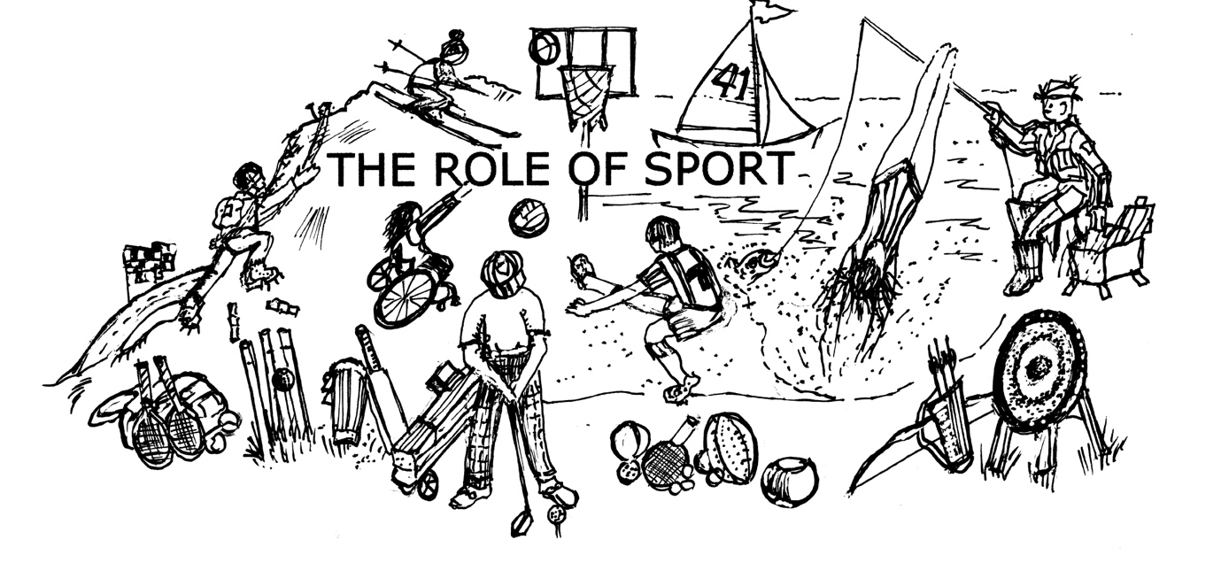

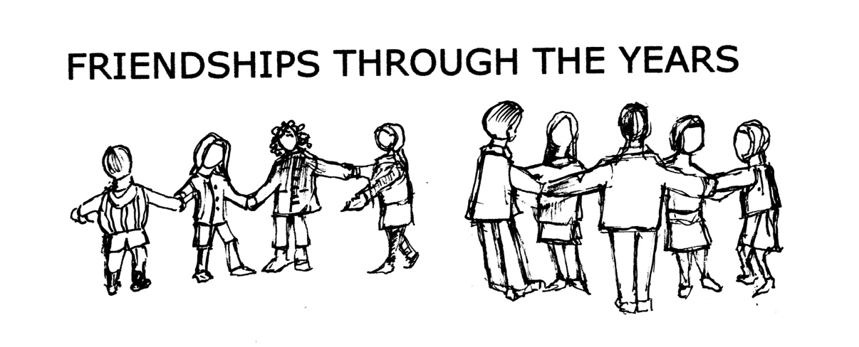

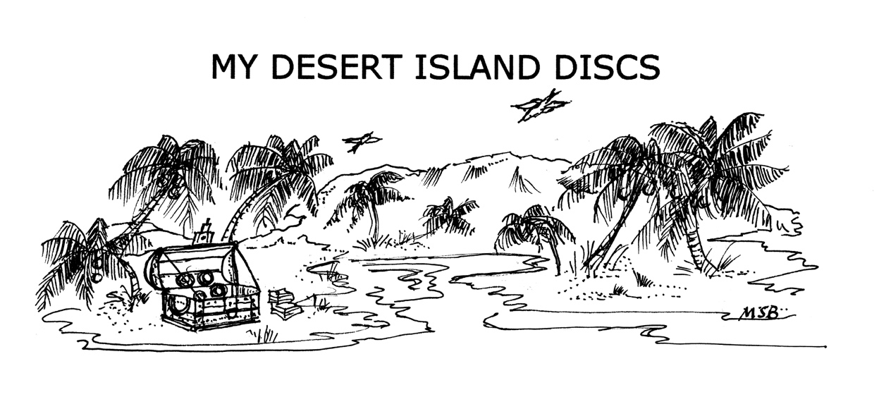

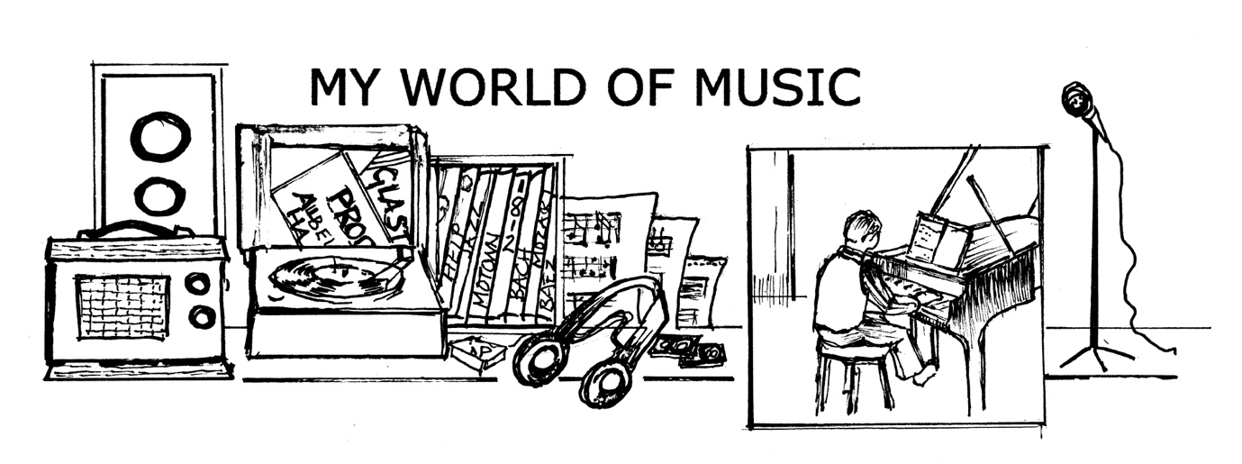



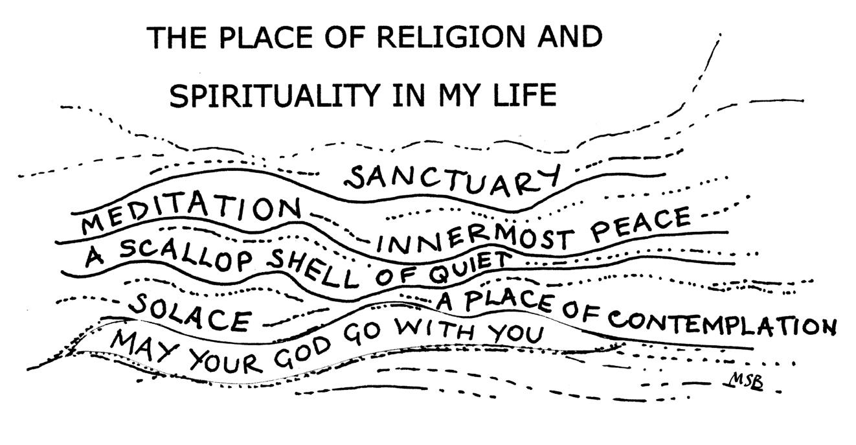

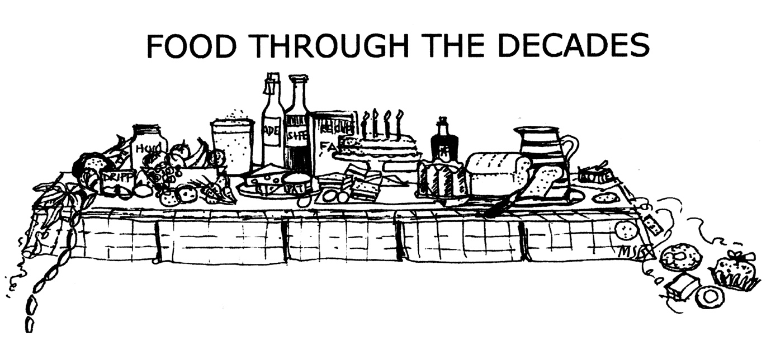

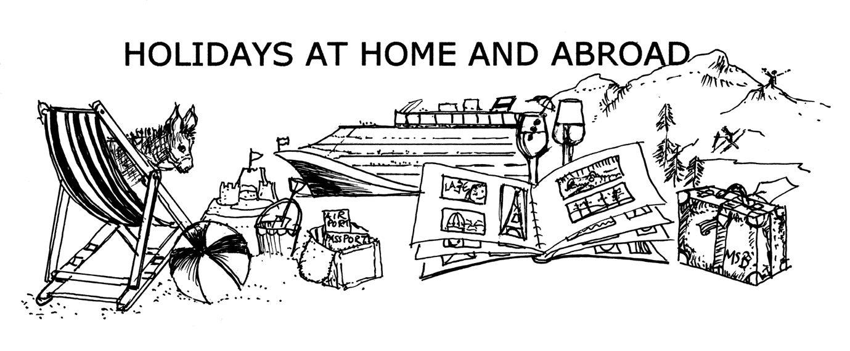

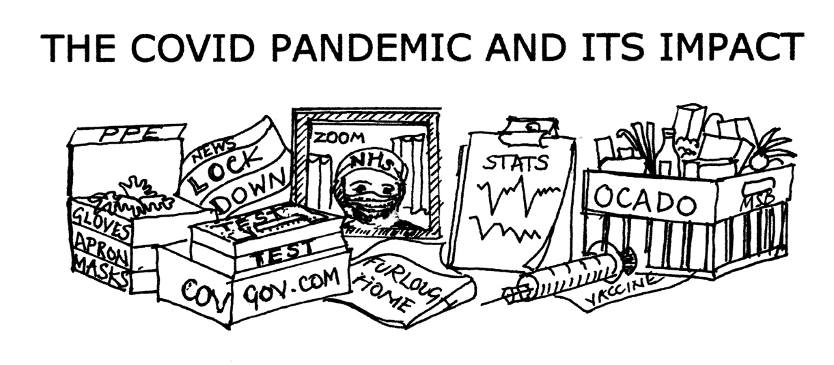

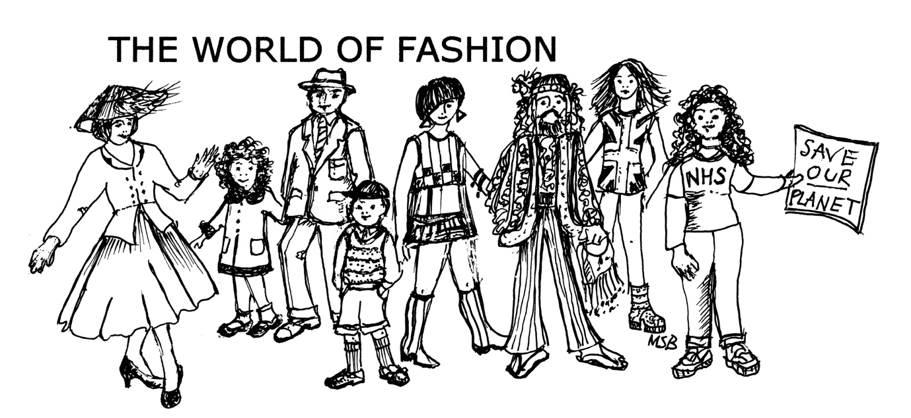

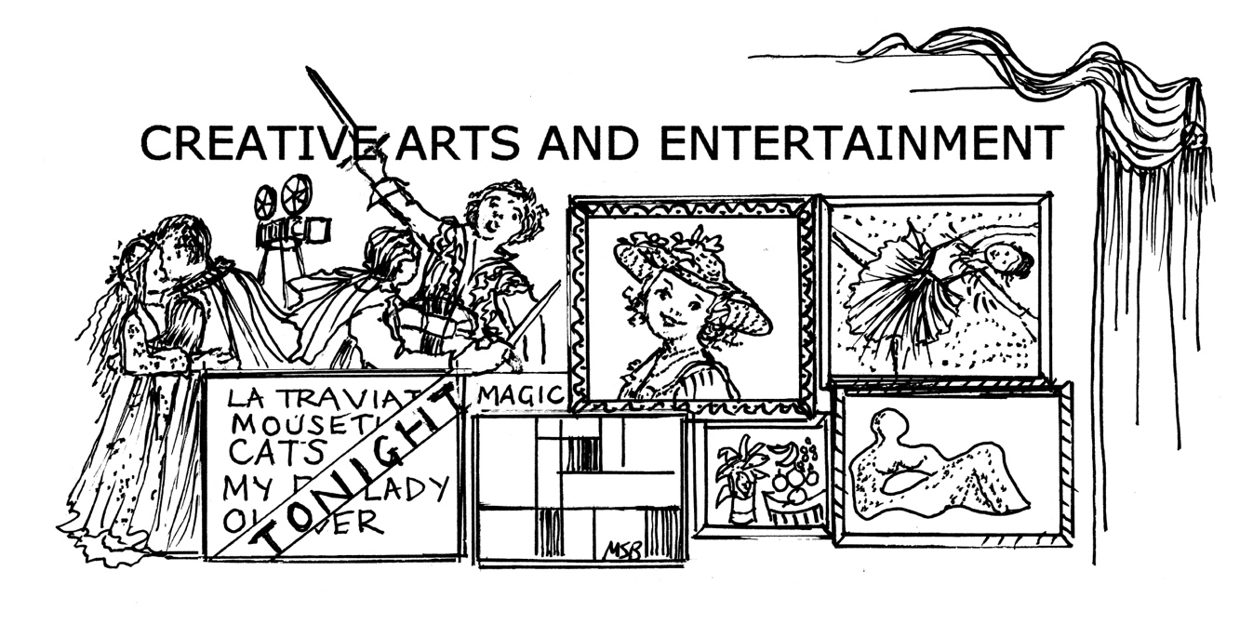

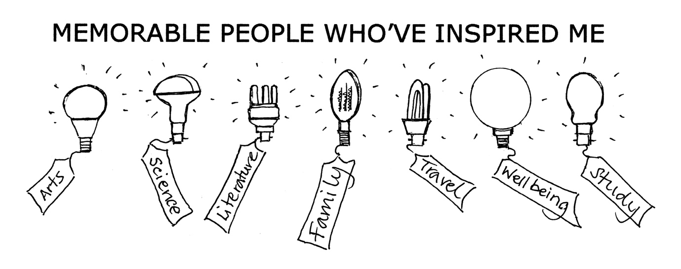



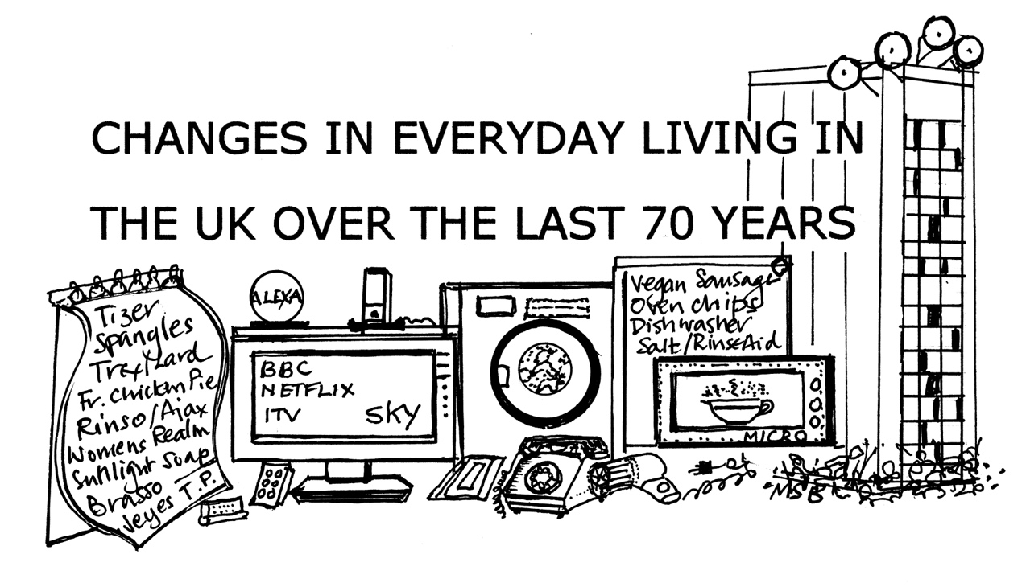

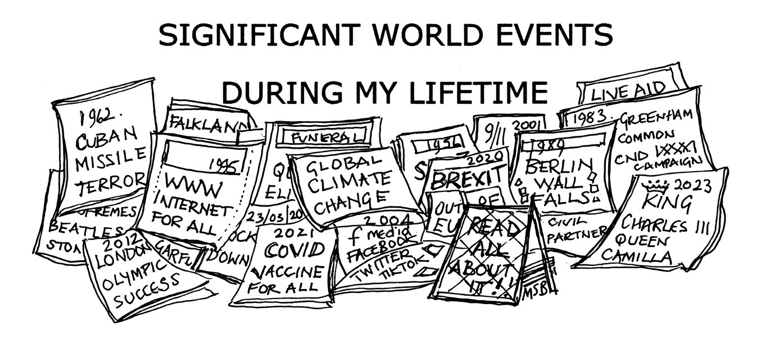

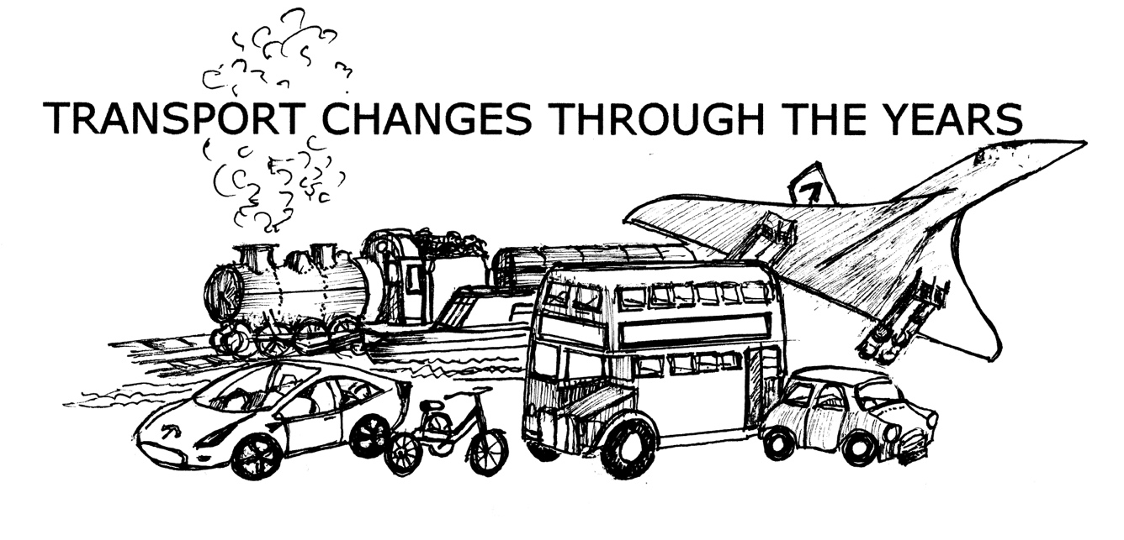

NOT ONLY BUT ALSO

NOT ONLY BUT ALSO

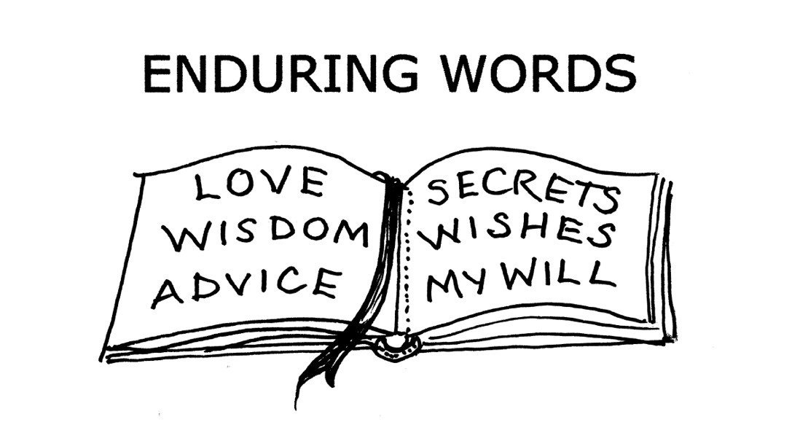

Step Four: Poems, an optional step
- If you decide to end your story after Step Three you won’t need the following pages. Well done! Your mission to write your life story is complete. Congratulations. Print off your work and delight family members and friends with your memoirs.
- The remaining pages are for those who wish to end their stories with a poem or two. Please refer to the Step-by-Step Guide (page 13) or refer to Appendix B in the Appendices. You may add as many pages as you wish.
- But…..you may continue your story with information, documents, illustrations, photography pages, additional family tree information or whatever you feel inclined to include.
- ‘From here I can go anywhere I choose.’*

*Wendy Cope poem ‘New Season’

